Startup creation

* **Challenge type: Conception, creation**
* **Team Challenge:** Groups (3 to 4)

# Part 1 : Define a startup

### **Brainstorming**

First, find an idea, a concept and a name. Brainstorm, with the tool you want. It can be a product, a service, a place, whatever, even unrealistic. This is when your imagination should take over.

Learn about the double diamond method:

* What is it?
* Why is it used?

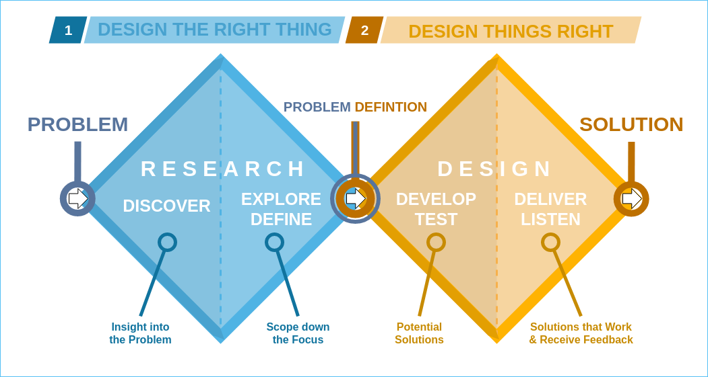

## 

### **Problematization**

The goal here is to define the problem by answering three questions:

* What are the project needs? The answer should be formulated in **one single sentence**
* Why is our project so great?
* What prevents us from carrying out our project?

**In a nutshell => Needs ?  Answer ?  Constraints ?**

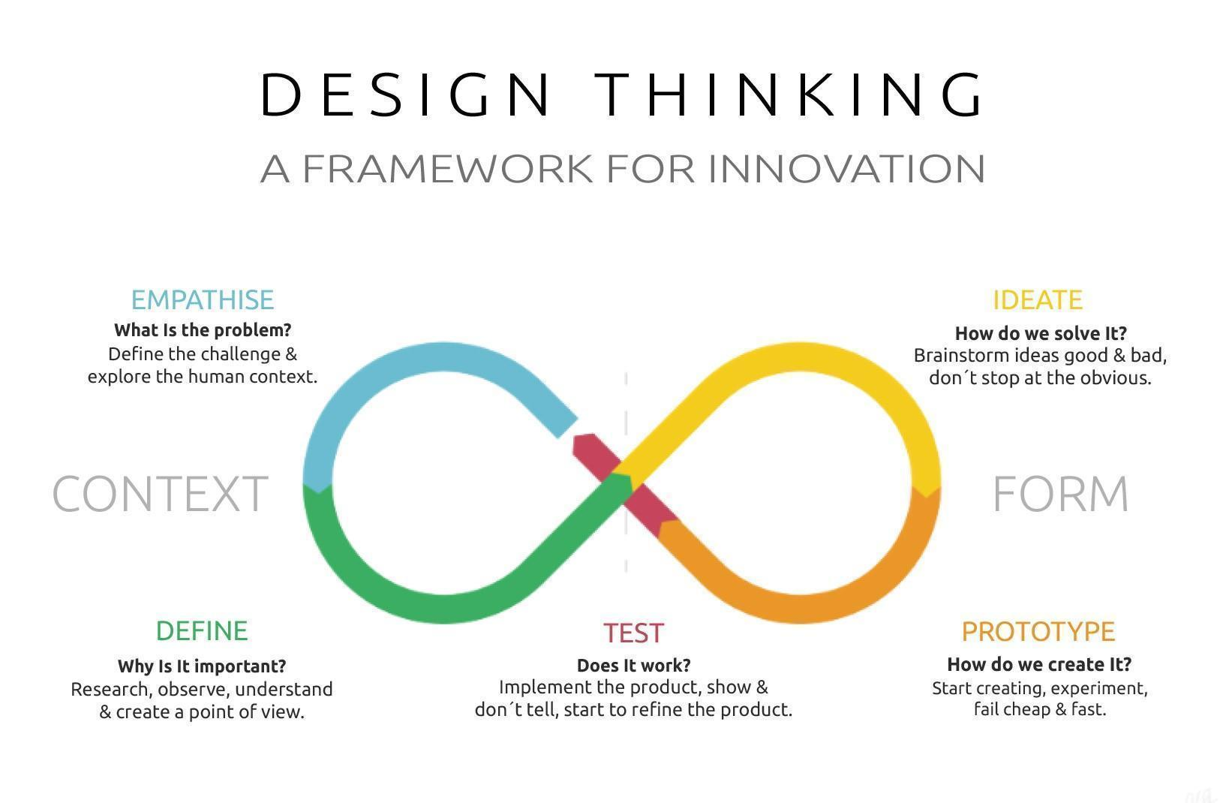

### **Mind-Mapping**

Mind-mapping consists of summarizing a subject in the form of a tree, or “octopus”, starting from general words and then diving progressively into details. It's sort of cleaning up your brainstorming and making it easy for an outside speaker to understand.

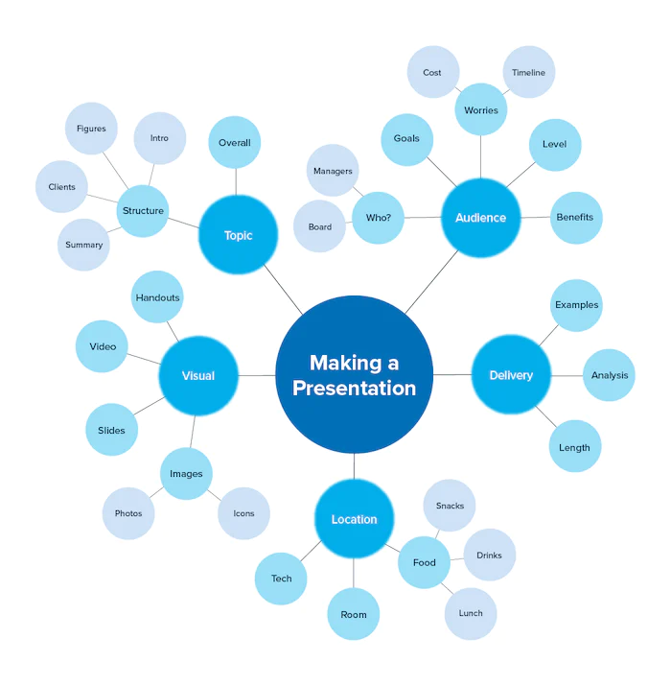

Summarize your project. If you send this document to a client or investor, they should immediately understand the purpose of your project.

The goal is to define the general concepts of your project, not yet to answer the problems ! (Everything about creating the logo, the GUI, the slogan, that's for later)

# Part 2: Specifications

The specification is the stage where the project is established. It is then a question of

* Drawing up the needs that shape the product to be created
* Finding the solutions.

It's up to you to look in your browser for what a specification looks like and to imitate the examples you find. You will use your previous work of brainstorming, problematization and mind-mapping.

### **Deliverables**

* Documentation on Google Drive (Doc, etc.)
* Drafting specifications
* Send your specifications to your client (your coach) by e-mail

# Pedagogical Objectives

* Use research and reflection methods to develop a project in a group and alone
* Be able to draw up specifications
* Be able to write a professional email